|  |  |
| --- | --- |
| Guide for  PGS System Monitor | |
|  | |
| Description: hp_logo | |
|  | |
| Version: | 1.0 |
| Effective Date: | 01-2012 |

# Revision History

|  |  |  |  |
| --- | --- | --- | --- |
| **Version** | **Date** | **Author** | **Comment** |
| 1.0 | 01/16/2012 | PGS Team | Initial Draft |
|  |  |  |  |
|  |  |  |  |
|  |  |  |  |
|  |  |  |  |
|  |  |  |  |
|  |  |  |  |

# Document Overview

Here are some guides to monitor PGS system includes below applications:

1. PGS Service
2. PGS Admin Site
3. PGS CVN
4. PGS Recon
5. RMS/FQM

# Applications

## PGS Service

### URL

<https://vpgsws.atlanta.hp.com/PGSWebService/Inquire.asmx>

### Expected Result

PG\_Inquire Page:

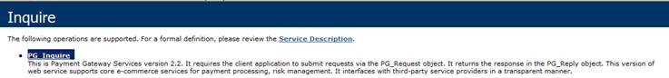

### Monitoring Steps

* Click PGS Service URL and you should see the expected page as above.

-------------------------------------------------------------------------------------------------------------------------------

## PGS Service v3.0 (OPS)

### URL

https://g5w2050.atlanta.hp.com/PGS30/PGSWebService/Inquire.asmx

https://g5w2051.atlanta.hp.com/PGS30/PGSWebService/Inquire.asmx

https://g5w2052.atlanta.hp.com/PGS30/PGSWebService/Inquire.asmx

https://g6w0330.atlanta.hp.com/PGS30/PGSWebService/Inquire.asmx

https://g6w0331.atlanta.hp.com/PGS30/PGSWebService/Inquire.asmx

https://g6w0332.atlanta.hp.com/PGS30/PGSWebService/Inquire.asmx

https://vpgsws.atlanta.hp.com/PGS30/PGSWebService/Inquire.asmx

### Expected Result

Inquire.asmx page:

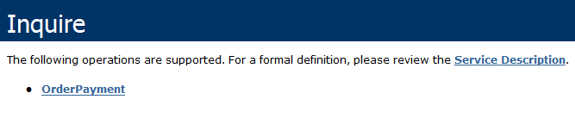

### Monitoring Steps

* Click PGS Service v3.0 URL and you should see the expected page as above.

-------------------------------------------------------------------------------------------------------------------------------

## PGS AdminSite

### URL

<https://vpgsadmin.atlanta.hp.com/pgsreport/default.aspx>

### Expected Result

* You should find that the most recent order is within minutes of the current GMT time
* You should not find a lot of errors in the Application RFlag Column.

### Monitoring Steps

* Click PGS AdminSite Url and run the Transaction Detail Report, you should see the expected results as above

-------------------------------------------------------------------------------------------------------------------------------

## PGS CVN

### URL

<https://vpgscvn.atlanta.hp.com/PGSCVNManagement>

### Expected Result

* The website can be opened without any errors.

### Monitoring Steps

* Click PGS CVN URL

-------------------------------------------------------------------------------------------------------------------------------

## PGS PHC

### URL

[https://phc.atlanta.hp.com/phc](%20https://phc.atlanta.hp.com/phc)

### Expected Result

* Message: “***Sorry, an error occurred while processing your request. “***.

### Monitoring Steps

* Click URL above

-------------------------------------------------------------------------------------------------------------------------------

## PGS Tokenization Service

### URL

[<https://vpgsws.atlanta.hp.com/PGSTokenization/Tokenization.asmx>](%20https://phc.atlanta.hp.com/phc)

### Expected Result

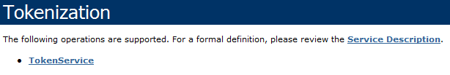.

### Monitoring Steps

* Click URL above

-------------------------------------------------------------------------------------------------------------------------------

## PGS Recon

### Server

Batch Server: gvw0983.americas.hpqcorp.net

### Expected Result

* No error E-mails sent from “PGS\_Reconciliation\_Error@hp.com” .
* Tidal is running.
* (Tidal) No errors occurred in Tidal system.

### Monitoring Steps

* Check Error E-Mail
* Check Tidal is running:
  + Go to share folder:  
    [\\gvw0983.americas.hpqcorp.net\F\_Drive\PGSApp\PGSReconciliationPlatform\Reconciliation.Files\Log](file:///\\gvw0983.americas.hpqcorp.net\F_Drive\PGSApp\PGSReconciliationPlatform\Reconciliation.Files\Log)
  + Sort by “Data Modified”
  + There are log files for current day (GMT time).

-------------------------------------------------------------------------------------------------------------------------------

## RMS/FQM

### URL

RMS: <https://vrms.atlanta.hp.com/decision/entryservletxml>

FQM: <https://vfqm.atlanta.hp.com/fqm/LoginRequired.do?banner=false>

RMS Admin: <https://g6w0333.atlanta.hp.com:8002/admin/login.jsp>

### Expected Result

* RMS: Below screen should be displayed

cid:image002.jpg@01CCBBD7.74AC6680

* RMS Admin: Below screen should be displayed

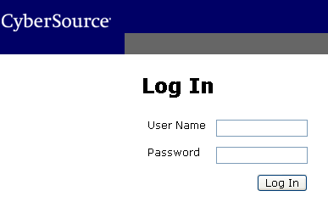

* FQM: Below screen should be display

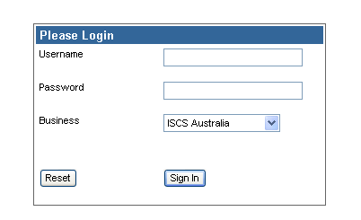

* Health status check: See 3.4.3

### Monitoring Steps

#### Health Status Page:

* Hosted in Dev URL - <https://d9w0328g.houston.hp.com:7002/healthstatus/>
* Hosted in ITG URL - <https://g4w1200.houston.hp.com:7002/healthstatus/>
  + Ensure that 4 FQM managed servers are running in ATL5 ONLY
  + Ensure all 12 RMS managed servers are running in ATL5 and ATL6
  + Ensure that RMSAdmin\_Pro1\_Server1 (g6w0333) is running   
    (no issue if the other RMS Admin managed server is running but not used)
  + ACTION – If any are not running as listed above, require a restart of the managed server impacted by GOC Support.

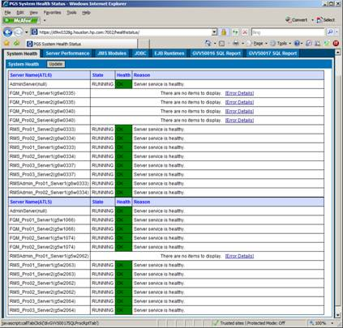

Go to the JMS Modules Tab and confirm there are no high numbers listed in the Messages Pending Column of the various modules.  
REMEMBER:  FQM only runs in ATL5, so any errors with FQM in ATL6 are expected.  
ACTION – If any have high pending counts, require a restart of the managed server impacted by GOC Support

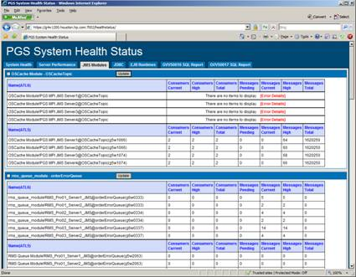

* + Go to the JDBC Tab and confirm the appropriate data sources are running.  
    REMEMBER:  FQM only runs in ATL5, so any errors with FQM in ATL6 are expected.

ACTION – If any are suspended or stopped, require a restart of the managed server impacted by GOC Support.

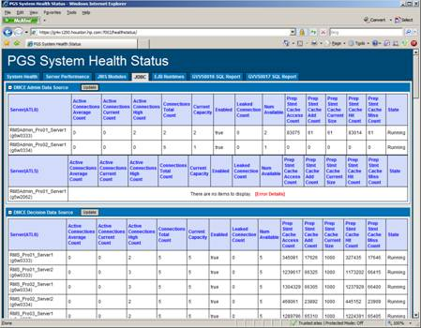

* + Go to the EJB Tab and confirm the appropriate are running and connected (as highlighted below).
  + REMEMBER:  FQM only runs in ATL5, so any errors with FQM in ATL6 are expected.

ACTION – If any are suspended or stopped, require a restart of the managed server impacted by GOC Support.

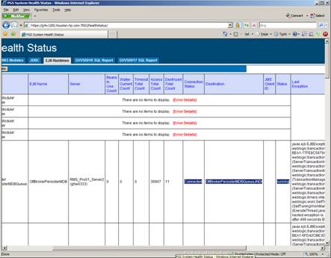

#### Check Orphan Order Count

During the SQL jobs on Saturday, cause several orders to have issue and cause orphans.  These orders should be cleaned up as part of the Sunday Tidal job (FQMDeleteInconsistentOrder\_DATAUPDATE); however a bug was found that prevents all orders to be cleaned up.  If the volume is low, these orders typically do not cause an issue; however, we want to keep this count low.

* Run the below script to determine the current count.

|  |
| --- |
| USE FQM  select COUNT(\*) FROM RM\_ORDER o  WHERE o.ORDER\_ID not in (SELECT response.ORDER\_ID FROM RM\_RESPONSE response)  and o.WAS\_READ=0  GO |

* If the amount is high, you will need to ask GOC Support to run the *JobDataUpdate\_FQMDeleteInconsistentOrder.bat* job located at *F:\PGSApp\PGSReconciliationPlatform\Reconciliation.Files\Task* on the Batch Server (gvw0983.atlanta.hp.com) 24 hours after the orders were created.
* You can find the order create date by running the below script to ensure you wait the 24 hours:

|  |
| --- |
| USE FQM  SELECT o.ORDER\_ID, o.MERCHANT\_REF\_NUMBER,o.datecreated  FROM RM\_ORDER o  WHERE o.ORDER\_ID not in (SELECT response.ORDER\_ID FROM RM\_RESPONSE response)  and o.WAS\_READ=0  order by DATECREATED desc  GO |

#### Order Backlog

Orders are picked up at a rate of 100 orders every 2 minutes.

This count typically can be close to 100; however, you should find this count returning to zero or very close.  However, if there are orphan orders, then this count will include these orphans that will never clear.

* Ensure the orders are persisting in a timely manner by running the following script:

|  |
| --- |
| USE FQM  select COUNT(\*) from RM\_ORDER where WAS\_READ = 0 |

If order volume is very high, ask GDBA to run the following SQL script to auto accept approve/decline orders

|  |
| --- |
| USE FQM  update  rm\_order set was\_read=1  where was\_read=0 and rm\_order\_status in('100','101')  GO |

### Troubleshooting

#### Failed to Restart Server If failed to restart any managed server from Weblogic console, ask support agent to log in the physical server and open the file listed below.  It should show process ID of running managed server.  Ask support agent to kill it.  Then restart server from WL console again.

E:\bea\user\_projects\domains\domain\_name\servers\managedserver\_name\data\nodemanager\managedserver\_name.lck

(ex.E:\bea\user\_projects\domains\RMS\_FQM\_domain\servers\FQM\_ITG01\_Server1\data\nodemanager\FQM\_ITG01\_Server1.lck)

#### Search Server Log Run the log file search tool - <http://d9w0328g.houston.hp.com:7001/CheckLogPRO/> from firefox.  It enables you to search for any error in the selected PRO log file (FQM/RMS/RMSadmin log files).